www.SteamEngineFinancialCoaching.com

How to Get Some Extra Money

One of the most effective ways of getting more money is by creating and following a written monthly spending plan. Here are some additional ideas to help you get some extra money, whether it is for paying off debt, saving up emergencies or making a special purchase:


Earn Some Money
- Work extra hours at your present job .
- Get a second job, e.g. deliver flowers, newspapers or pizzas, be a crossing guard or lunch monitor at a school, bus tables, work as waiter or a sign holder.
- If you are a professional, do some contract work on the side.
- Do some odd jobs like babysitting, walking the neighbor's dog, pet sitting, painting, cleaning, yard work, etc.

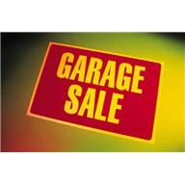
Sell Something for Money
- Sell some things on craigslist.org—it's free.
- Have a garage sale.
- Rent out a spare room in your home.
- Sell unwanted stuff—see the local resources listed here.

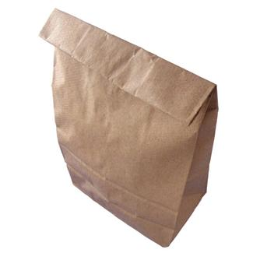
Save Money
- Bring your lunch to work instead of eating out.
- Skip the Starbuck's
- Stop eating out for a while, or cut back the number of times eating out.
- Wait on taking that trip.
- Cancel the gym membership if you can exercise enough by walking with a friend, lifting weights at home or cycling to work (saves on gas, too!).
- Give up paid services and do the work yourself, e.g. car wash, maid, carpet cleaners, lawn service, exterminator.
- Opt for free or very inexpensive entertainment: borrow books, magazines and videos from the public library, cancel cable television and try hulu.com or Netflix.
- Drink water instead of soda or make your own instant drinks like iced tea or powdered lemonade.
- Plan your week's meals according to what's on sale that week.
- Avoid impulse buys at the grocery store by only buying what's on your grocery list.
- Give personal gifts instead of more expensive store-bought gifts, like a framed photo, a poem or a home-made coupon for spending time together or doing someone's chore for him or her. (For your own birthday, let people know about your savings goal in case they'd like to help by giving you cash.)
- Empty out your storage locker and stop paying that monthly bill. Sell the stuff you don't need now. (You can always get more stuff later.)

Some Local Resources for Selling Your Stuff

General
Craigslist
www.craigslist.org

Ebay
www.ebay.com

Capital City Loans and Jewelry
200 Atlantic St
Roseville, CA 95678
(916) 786-6669
www.capcityloan.com

Books
Almost Perfect Book Store
1901 Douglas Blvd # 130
Roseville, CA 95661
(916) 781-7935

The Book Haven
884 Lincoln Way
Auburn, CA 95603
(530) 888-0229
www.auburnbookhaven.com

Clothing and Accessories
Sei Bella Boutique
1950 Douglas Blvd., Ste. A3
Roseville, CA 95661
(916) 789-0404
seibellaboutique.com

Deja Vu in a Dress
1730-1 Santa Clara Drive
Roseville, CA 95661
(916) 780-4222
www.dejavuinadress.com

Furniture and Home Decor
Home Consignment Center
5761 Five Star Blvd
Roseville, CA 95678
(916) 784-2427
www.thehomeconsignmentcenter.com

Sei Bella Boutique
1950 Douglas Blvd.
Roseville, CA 95661
(916) 789-0404
seibellaboutique.com

Jewelry
The Gold Refinery (host a gold party)
Kitty Good, certified gold specialist
Associate ID 902274
www.gogoldrefinery.com/kgood
(916) 955-9347
The Gold Guys
Creekside Town Center
1210 Roseville Parkway
Roseville, CA 95678
(916) 772-2121
Arden Jewelers
2800 Arden Way
Sacramento, CA 95825
(916) 481-8006
www.mygemologist.com

Rocklin Coin Shop
4870 Granite Drive
Rocklin, California 95677
(916) 315-0888
www.rocklincoinshop.com

CD's, DVD's & Video Games
GameStop
The Galleria Mall, 1151 Galleria Blvd # 210
Roseville, CA‎ 95678
(916) 788-4490‎
www.gamestop,com
Dimple Records
1701 Santa Clara Drive
Roseville, CA 95661
(916) 781-2800
www.dimple.com

